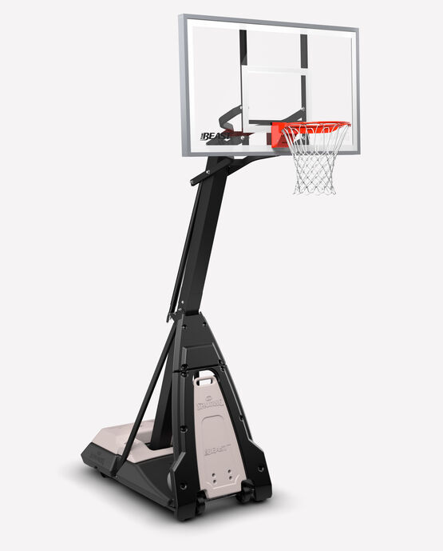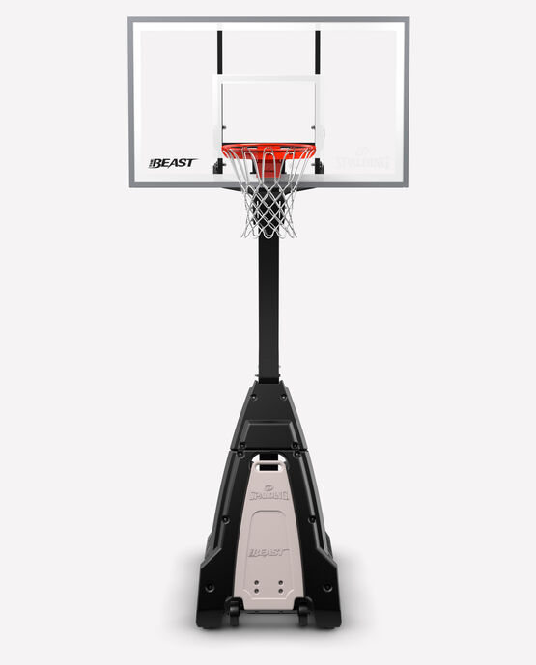 Spalding’s Beast Portable Basketball Hoop

Giving you the stability and reliability of an in-ground hoop The Beast Portable Basketball Hoop is the only portable system of its size. With infinite adjustability from 7.5 feet to 10 feet with a screw jack lift system this hoop is easy enough for anybody to use. Transporting and moving the hoop is made simple with the integrated 4-wheel base, allowing for easy mobility without having to tilt forward. So whether you're honing your skills, organizing neighborhood tournaments, or simply enjoying a casual game with friends and family, The Beast Portable Hoop is the ultimate choice for that professional-grade experience in your own driveway.

**DETAILS:**

* Backboard size: 72", 60", and 54" available
* Tempered glass or performance acrylic board
* Steel board frame with aluminum trim
* Arena Slam, and Steel Pro Image breakaway rim available
* 7.5' to 10' height adjustment
* Screw Jack lift
* 4" or 5" Apex Angle™ square steel pole
* Power Move® Base fills with 40 or 55 gallons of water or sand